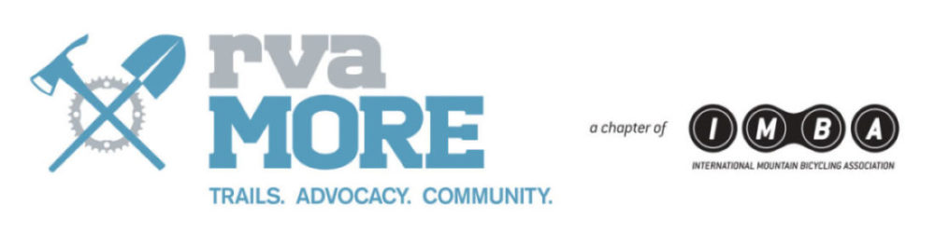

**rvaMORE Board of Directors Meeting Minutes**

Date and Time of Meeting: 11/29/17, 6:00 p.m.

Location: Reedy Creek

Members Present: Greg Rollins, Travis Guilbeau, Jill Williams, Roger Sattler, Kitt West, and Kendell Ryan

Members Absent: Ross Moorefield, Michael Taliaferro, Clark Jones,

Marysa Burchett, and Ann Gongora

Guests Present: Michael Burton (JRPS Trails Manager)

Purpose of Meeting: Regular board meeting - see attached agenda.

The meeting began at 6:10 pm.

Note there is no board meeting in December. The next board meeting is January 17, 2018.

**TRAVIS/FINANCIALS**

Travis noted that we currently have $33,000 in the operating account. The following notes are current and upcoming projects to use some of those funds.

Travis received an invoice from Clark on an Canyom - $6,950.00 for the third Canycom – statement date of 11/1. Travis is pretty sure this already paid and will validate the payment.

The recent SportsBackers donation (received at Tour de Fall Line) from RiverRock was used for rebuilding the Northbank dog-leg bridge (first bridge on NorthBank heading west).

**MICHAEL BURTON/JRPS UPDATE**

Michael Burton updated the Board on the following trails:

**North Bank**

There is a place on Northbank known as the “Stump Dump” between Hollywood and Riverview which will need armoring.

**Buttermilk**

Action Item: Greg to post a message on Facebook with the upcoming change on Buttermilk. Post will include details of the plan, city letter, and the trail forks map.

A reroute will be done which will take place between 30th street and 22nd street. There will be a new technical line and a higher less technical trail. Later in the development, a post on Facebook will go out for a survey to get ideas for technical features one the line, which is more technical. This line is good for a rocky section.

Another project, close to the Nickel Bridge, will have a fun reroute.

**Dogwood Dell**

Survey went live on Facebook to determine if people want the Dogwood Dell trail to be directional. If it’s decided to go directional, there will be 2 predominant signs, one at the bottom and one at the top.

**Gillies**

There are a few to-dos remaining. We need to get maps and signs on the kiosk. Ross is still working on the signs.

Kitt to schedule with Mike Burton 1 or 2 work days to complete the trails. There are three main lines, which are working to be finished. Sometime in Spring, there will be a grand opening.

Kitt requested a Jobox. Action Item: Kitt to do pricing/research on joboxes. Recommending $500 in budget for it.

Kitt will be working on building YouTube skits, which demonstrate trail building. This will provide educational information on different ways to help with trail building.

**Trail Class**

Class 101 recap:

There were 18 people at trail class, which went very well. Additional work needs to be done, but there will be scheduled work days to finish the work.

Action Item: Greg is to send out a thank you letter for those who attended the trail class.

**POCAHONTAS UPDATE**

Update from Greg –

Trails 12, 15c and 15d are officially open! Trail 12 name is “Corkscrew”. The Park will put out a contest for a name on15c and 15d.

Scott Linnenburger and Jeremy Winpey will be in town the second week in December, and the new trails will be reviewed for signage. A risk management report will be available in January.

Trail 11 is still being built and is not open to the public just yet.

It was noted that rvaMORE is in need of more volunteers from the community and members to help with the continual construction of the Pocahontas area.

**COMMITTEES UPDATE**

**Events**

December 12: Holiday Social: Discussed planning of the holiday social. Planning for approx. 50 people for food. Everyone on the board will need to download the square app. We will need help with purchases. Action Item: Jill will follow-up if there is anyone who can provide a sound system for the holiday social and future.

There was discussion of considering an event/get-together for the board in 2018.

Roger recommends getting some of the board to attend events/meetings up in NOVA.

**Grants**

Greg is working on the IMBA Grant.

**Website**

Jill is to work with Brent Hiller on ideas for website. For the trails page, potentially use a gallery widget. Jill will work with Brent on the trails page and integration with TrailForks. TrailForks has an event app. Jill will look into this app and report back.

The rvaMORE calendar is not up to date -- the goal is to have a single place for items to be updated and distributed.

Another goal is to have the storefront available by March 2018.

**Miscellaneous**

Discussed intentions of existing members and staying on the board for 2018. The following board members have confirmed they are staying in 2018:

Greg Rollins, Travis Guilbeau, Marysa Burchett, Jill Williams, Roger Sattler, Kitt West, Kendell Ryan, Ross Moorefield, Michael Taliaferro, and Ann Gongora.

Greg will follow-up with Clark on his intentions.

The meeting adjourned at 8:40 PM

*If you are interested in sitting in on a board meeting, please let us know (email us at info@rvamore.org) and we will give you the what/when/where of the next meeting along with the secret handshake. Meetings typically last from 6 p.m. to 9 p.m. Additionally, if you have any questions about anything we do, please email us. We’re happy to answer your questions.